SIMATS ENGINEERING
ASSESSMENT TOOL 3

COURSE CODE: CSA14 COURSE NAME: Compiler Design

COURSE OUTCOME COVERED
CO4: Examine intermediate code generation techniques to enhance code optimization (BL4)
Assessment Tool Weightage: 10%

QUESTIONS: Total Marks:50
Annexure A

CONCEPT MAPPING

Code of Conduct:

I Sarika K S (192521039) (Name / Reg No) certify that this submission is my original work and that I have adhered to the guidelines specified for this assessment.
I understand that any violation of academic integrity rules will result in disciplinary action.

Signature of the student:

Annexure A

CONCEPT MAPPING

1.Intermediate Language and Declarations
2.Assignment Statements and Boolean Expressions
3.Case Statements and Backpatching

RUBRICS FOR CALCULATION

Criteria | Weightage | Level 4 (Exemplary) | Level 3 (Proficient) | Level 2 (Developing) | Level 1 (Beginning)
Understanding of Data | 25% | Accurately interprets all data patterns, trends, and relationships | Interprets data correctly with minor gaps | Partial understanding; misses key trends | Misinterprets or fails to understand data
Analysis | 25% | Provides deep analysis with strong logical reasoning and justification | Provides reasonable analysis with some justification | Basic analysis with weak reasoning | No meaningful analysis provided
Application of Concepts | 20% | Effectively applies relevant concepts/tools to interpret data accurately | Applies concepts with minor errors | Limited application; requires guidance | Unable to apply concepts to data
Conclusion | 20% | Draws clear, meaningful conclusions with strong insights and implications | Provides valid conclusions with moderate insights | Conclusions are vague or weak | No clear or valid conclusions
Clarity | 10% | Presents interpretation clearly using proper structure, visuals, and terminology | Generally clear with minor issues | Lacks clarity or proper structure | Poor presentation and difficult to understand

1.Intermediate Language and Declarations

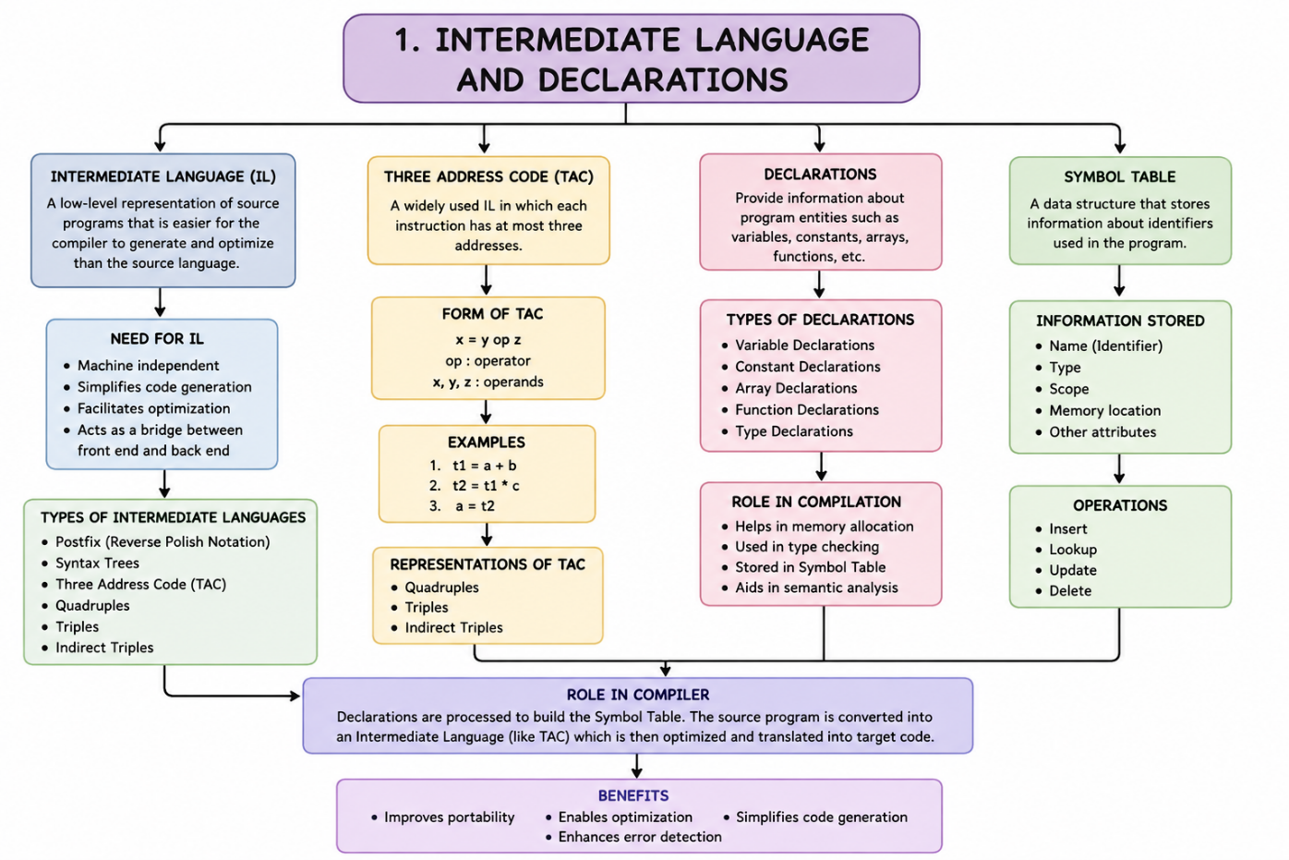
2.Assignment Statements and Boolean Expressions

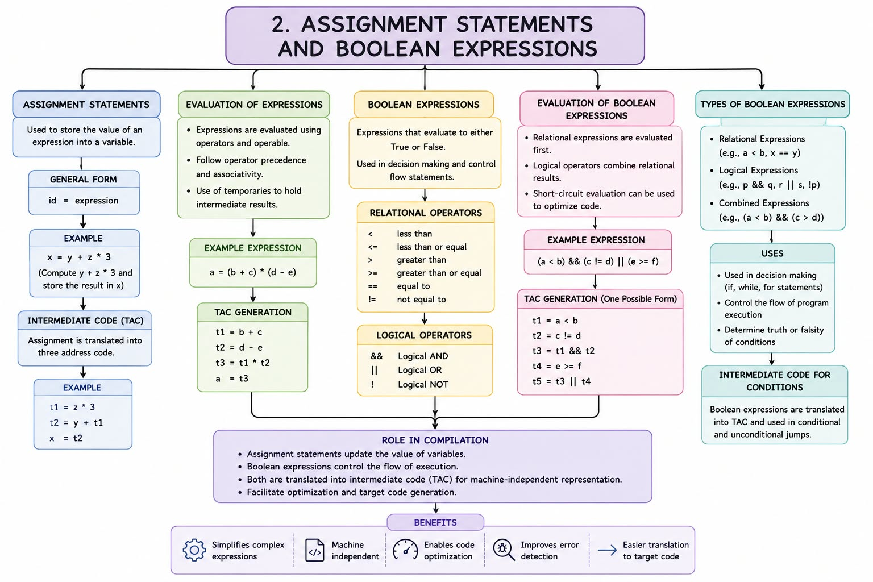
3.Case Statements and Backpatching
